**Identification of binary attributes related to high acceptance rates for Coffee House coupons**

I analyzed attributes that contributed to high rates of acceptance of Coffee House coupons (CC). I approached this first by plotting the rate of coupon acceptance for any given attribute in each category of data (**Fig**. 1). The only excluded category was related to ‘car’s as the majority of this data were empty. The red line in **Fig.** 1 shows the average acceptance rate for CC, 50%. Values higher than this are demonstrate a higher probability of CC relative to the basal CC. The top three single attributes that correlate with high CC are: {Occupation: Healthcare Practitioners & Technical; CC = 76%, Age: below 21; CC = 70%, CoffeHouse Visit Frequency: 4-8; CC = 69%} (**Fig.** 1). I then asked whether or not binary combinations of attributes that result in the highest CC for a given category result in even higher CC. For example: “What is the CC for healthcare practitioners that go to a CoffeeHouse 4-8 times a month?”. I made a simple heat map (**Fig.** 2) to investigate this, where the color represents CC and the number in the square represents the number of observations for the binary condition. The axes are each high CC attribute. We can see that the categories with very high CC tend to possess few (<100) observations and should therefore hesitate on generalizing some of the assumptions of this study. However, performing these analyses I found a few attribute tuples that result in extraordinarily high CC. For example, healthcare practitioners that go to more expensive restaurants >8 times a month have 100% acceptance rate, although only 10 observations of this exist. A more frequent attribute tuple with high acceptance rate is an income from 87500-99999 and >8 coffee house visits per month at CC = 90% and 42 observations. The top 20 CCs from binary attribute groups is given in (**Table** 1). We can see this type of Bayesian analysis is very powerful for identifying whether or not a person is likely to accept Coffee Coupons. This analysis can be applied to other accept conditions and can be further implemented at higher than binary dimensions, at the cost of higher compute.

**Figure 1**. Calculated CC of each category of attributes. The red line represents the average CC of 50%.

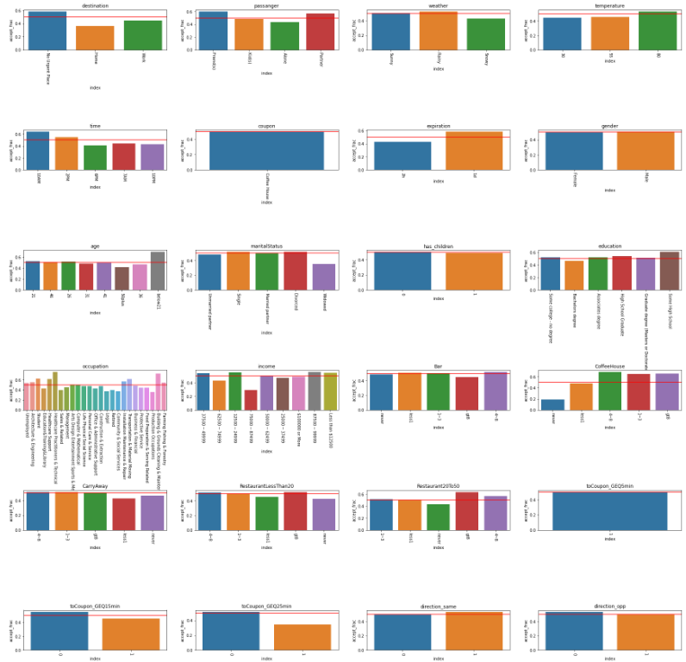

**Figure 2.** Heatmap colored by the probability of accepting a coffee house coupon (CC) and annotated with the number of observations of that type of individual just in case a single/few person(s) comprises that category. NULL values are white (instances where no individual satisfies both conditions).

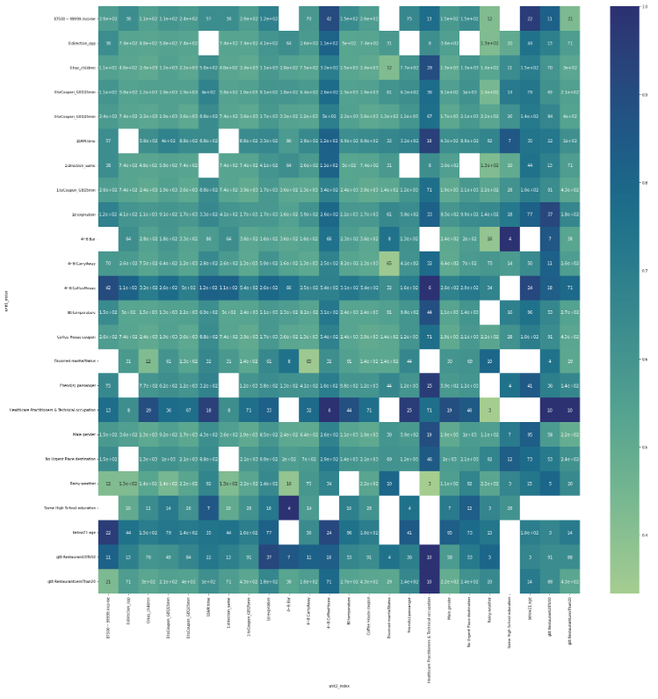

**Table 1**. Top 20 CC of groups that satisfy a binary set of high cc attributes.

